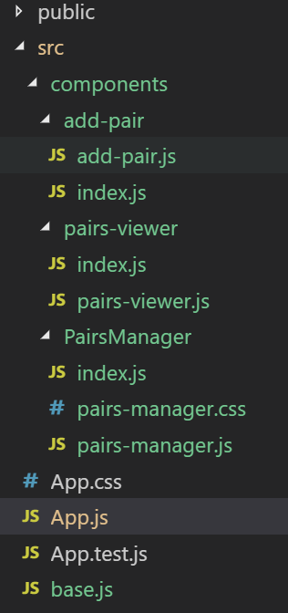Простий приклад використання роутів і rebase

Сторінка Home

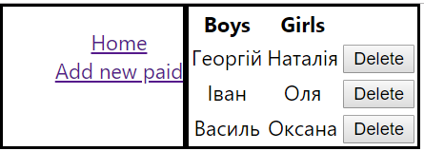

Сторінка Add

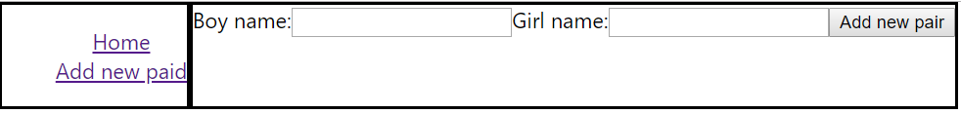

|  |  |
| --- | --- |
| Компонент AddPair | import React from 'react';  const AddPair = ({addNewPair}) => {  let boyInp, girlInp  return (  <>  <label>  Boy name:  <input ref={node=>boyInp=node}/>  </label>  <label>  Girl name:  <input ref={node=>girlInp=node}/>  </label>  <button onClick={()=>addNewPair(boyInp.value,girlInp.value)}>  Add new pair  </button>  </>  );  }    export default AddPair; |
| Компонент PairsViewer | import React from 'react';  const PairsViewer = ({ pairs, onDelete }) => {  return (  Object.keys(pairs).length > 0 ? (  < table >  <tr>  <th>Boys</th>  <th>Girls</th>  </tr>  {  Object.keys(pairs).map(id => (  <tr key={id}>  <td>{pairs[id].boy}</td>  <td>{pairs[id].girl}</td>  <td>  <button onClick={() => onDelete(id)}>  Delete  </button>  </td>  </tr>  ))  }  </table >)  : 'No pairs'  );  }  export default PairsViewer; |
| Компонент PairsManager | import React, { Component } from 'react';  import AddPair from '../add-pair'  import PairsViewer from '../pairs-viewer'  import { v4 } from 'uuid'  import { Link, Route,Switch } from 'react-router-dom'  import './pairs-manager.css'  import base from '../../base'  class PairsManager extends Component {  constructor(props) {  super(props);  this.state = {  pairs: {}  }  }  componentDidMount(){  this.db=base.syncState(`pairs`, {  context: this,  state: 'pairs',  });  }  componentWillUnmount(){  base.removeBinding(this.db)  }  addNewPair = (boyName, girlName) => {  const newId = v4()  this.setState({  pairs: {  ...this.state.pairs,  [newId]: {  id: newId,  boy: boyName,  girl: girlName  }  }  })  }  onDelete = (id) => {  const { pairs } = this.state  const newPairs = { ...pairs }  delete newPairs[id]  this.setState({  pairs: newPairs  })  }  render() {  const { pairs } = this.state  return (  <div className='main'>  <div className='nav'>  <ul>  <li>  <Link to='/'>Home</Link>  </li>  <li>  <Link to='/add'>Add new paid</Link>  </li>  </ul>  </div>  <div className='content'>  <Switch>  <Route path='/' exact component={()=><PairsViewer pairs={pairs} onDelete={this.onDelete} />}/>  <Route path='/add' component={()=><AddPair addNewPair={this.addNewPair} />}/>  </Switch>  </div>  {/* <AddPair addNewPair={this.addNewPair} />  <hr />  <PairsViewer pairs={pairs} onDelete={this.onDelete} /> */}  </div>  );  }  }  export default PairsManager; |
| Файл налаштувань firebase | import Rebase from 're-base'  import firebase from 'firebase'  var firebaseConfig = {  apiKey: "", 🡨 У ЦІ ПОЛЯ ДОДАЄТЕ СВОЇ НАЛАШТУВАННЯ  authDomain: "",  databaseURL: "",  projectId: "pairs-manager",  storageBucket: "pairs-manager.appspot.com",  messagingSenderId: "",  appId: ""  };  // Initialize Firebase  var app = firebase.initializeApp(firebaseConfig);  var base = Rebase.createClass(app.database());  export default base |
| Головний додаток | import React from 'react';  import logo from './logo.svg';  import './App.css';  import PairsManager from './components/PairsManager'  import { BrowserRouter } from 'react-router-dom'  function App() {  return (  <div className="App">  <BrowserRouter>  <PairsManager />  </BrowserRouter>  </div>  );  }  export default App; |
|  |  |
|  |  |
|  |  |